troubleshooting Checklist

# FIRST STEPS

Double check for typos! This is where many of your first errors will come from.

Variable names are constant throughout your program and are case sensitive. Double check for spelling errors.

Each data type (integer, string, bool, float) and data collection (list, dictionary, etc.) has their own set of functions/methods, make sure you are using the appropriate function given your variables type.

Use the print() function after each operation to ensure you are getting the intended output.

# READing THE OUTPUT

Python comes built in with a debugger that will let you know exactly where and why it did not understand your code.

Begin by reading the Error message, which is found at the end of the debug message. This will tell you what went wrong in your code. In the example below

Above that, the line of code with the error will be displayed. The exact location of the error will be highlighted with a “^” .

In the example below, a SyntaxError (Typo or missing values) is present. This is displayed at the bottom of the debug message, and the position directly after the “+” sign is highlighted with the “^” as I am missing the second value for the addition.

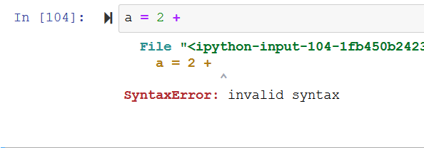

# Debuging jupyter

You might run into some issues with the development environment during the bootcamps. Here is one way of knowing you’ve encountered an issue and how to solve it.

Check the execution status of all the cells (value in brackets). If the value is [*] and not changing, chances are your session has crashed. See below for an example of a crashed session.

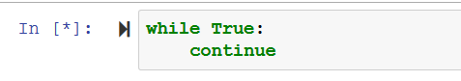

The first way of solving this is to interrupt the cell. To do this, click into the cell and then press the black square button in the toolbar. See below for a visual of where to find the “Interrupt Kernel” button.



If that does not help, restarting the session is always an option. To do so, under the “Kernel” tab you will find “Restart & Run All”. Click this and wait a few seconds. This will restart your session and run all the cells in the notebook. See below for a visual of where to find the “Restart & Run All” command.

